WAP to book a movie ticket, that follows the rule as:

1. Ticket can be booked before one hour of starting of the movie.
2. Cancellation can be done two hour before starting of the movie.

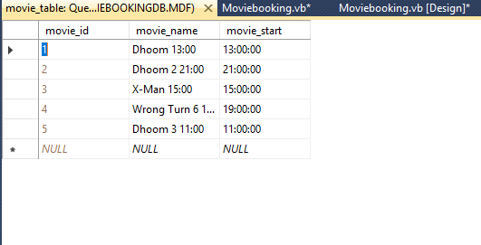

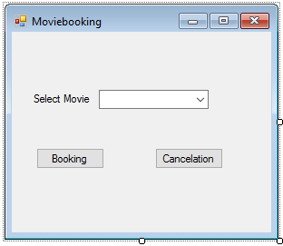

Imports System.Data.SqlClient

Imports System.Data

Imports System.Configuration

Public Class Moviebooking

Dim conString As String = "Data Source=.\SQLEXPRESS;AttachDbFilename=C:\Users\ktrim\Documents\Moviebookingdb.mdf;Integrated Security=True;Connect Timeout=30;User Instance=True"

Dim con As New SqlConnection

Dim cmd As New SqlCommand

Dim rd As SqlDataReader

Dim moviename As String

Dim start_time As TimeSpan

Dim temp As Integer

Private Sub Moviebooking_Load(sender As System.Object, e As System.EventArgs) Handles MyBase.Load

con.ConnectionString = conString

cmd.Connection = con

con.Open()

cmd.CommandText = "select * from movie_table"

rd = cmd.ExecuteReader()

If (rd.HasRows) Then

While rd.Read()

ComboBox1.Items.Add(rd("movie_name"))

End While

End If

rd.Close()

con.Close()

End Sub

Private Sub ComboBox1_SelectedIndexChanged(sender As System.Object, e As System.EventArgs) Handles ComboBox1.SelectedIndexChanged

con.ConnectionString = conString

cmd.Connection = con

con.Open()

cmd.CommandText = "select * from movie_table where movie_name='" & ComboBox1.Text & "'"

rd = cmd.ExecuteReader()

If (rd.HasRows) Then

While rd.Read()

moviename = rd.GetString(1)

start_time = rd.GetTimeSpan(2)

End While

End If

con.Close()

End Sub

Private Sub btnbooking_Click(sender As System.Object, e As System.EventArgs) Handles btnbooking.Click

Dim moviehour As Integer = start_time.Hours

Dim currenthour As Integer = DateTime.Now.Hour

temp = currenthour - moviehour

If (currenthour > moviehour) Then

MsgBox("Booking can only done before one hour")

Else

If (temp < -1) Then

MsgBox("Your movie is booked")

Else

MsgBox("Booking can only done before one hour")

End If

End If

'MsgBox(moviehour & " " & currenthour & " " & temp)

End Sub

Private Sub btncancelation_Click(sender As System.Object, e As System.EventArgs) Handles btncancelation.Click

Dim moviehour As Integer = start_time.Hours

Dim currenthour As Integer = DateTime.Now.Hour

temp = currenthour - moviehour

If (currenthour > moviehour) Then

MsgBox("cancalation can only done before 2 hour of movie start")

Else

If (temp <= -2) Then

MsgBox("cancalation is done")

Else

MsgBox("cancalation can only done before 2 hour of movie start")

End If

End If

'MsgBox(moviehour & " " & currenthour & " " & temp)

End Sub

End Class

Successful Booking Example:

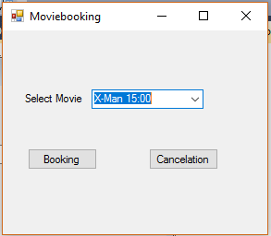

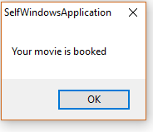

Error in Booking:

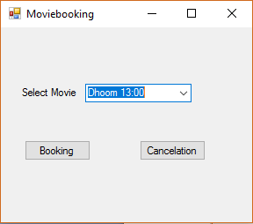

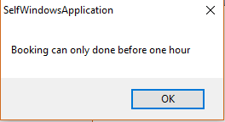

Successful Cancellation example:

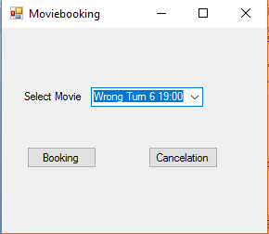

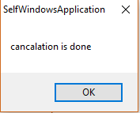

Error in cancellation:



